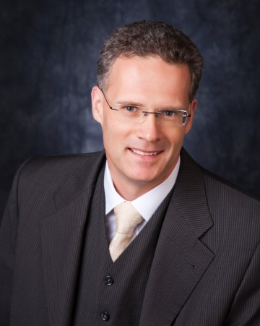 **Marcus Schabacker, M.D., PhD.**

Since July, 2014 Dr. Schabacker has served as Chief Scientific Officer (CSO) / Corporate Vice President (CVP) at Baxter Healthcare Corporation. In this role, he leads the Research & Development (R&D), Regulatory Affairs, Global Patient Safety, Medical Affairs, and Clinical Development organizations for Baxter and is responsible for driving innovation, enhancing its scientific technical and medical capabilities, and ensuring Baxter has a strong foundation of safety, clinical development, and regulatory support.

Prior to his appointment as CSO, Dr. Schabacker joined Baxter in March 2011 as the head of R&D for Baxter’s Medical Products business unit. He led the integration of multiple R&D teams into one global organization, enhancing performance and collaboration, aligning departments around core scientific competencies, and placing R&D resources closer to our global customer base, including those in fast-growing emerging markets such as China and India.

Prior to joining Baxter, Dr. Schabacker held the position of Senior Vice President and Chief Scientific Officer at ConvaTec, Inc. – a leading developer and marketer of medical technologies in ostomy care, wound therapeutics, continence and critical care, and infusion devices. In this role, Dr. Schabacker had global responsibility for R&D, Regulatory Affairs, Quality Management, Occupational and Environmental Health and Safety, Medical Affairs, and Clinical Research.

Prior to ConvaTec, Dr. Schabacker was Corporate Vice President, R&D at B. Braun Medical. Under his leadership, more than 10 new medical devices were launched and an innovation management program was implemented. He also established new clinical research and medical scientific departments.

Dr. Schabacker was also a consultant with Drägerwerg AG in Johannesburg, South Africa, where he played a key role in the introduction of a new ventilation system. As Senior Medical Officer at Mafikeng General Hospital, in the capital city of Mafikeng, North-West Province, South Africa, he established and led the Anesthesia and Intensive Care Medicine Department and also served as the Medical Lead for Disaster Planning.

Dr. Schabacker has an MD and a Doctorate in anesthesia from Medical University of Lübeck in Germany and certifications in Anesthesiology, Disaster Medicine, and Emergency Medicine.